ISCHGL, AUSTRIA
ISCHGL, ST. ANTON AND KRAKOW PACKAGE ($2,960)

ISCHGL: January 29th through February 6th

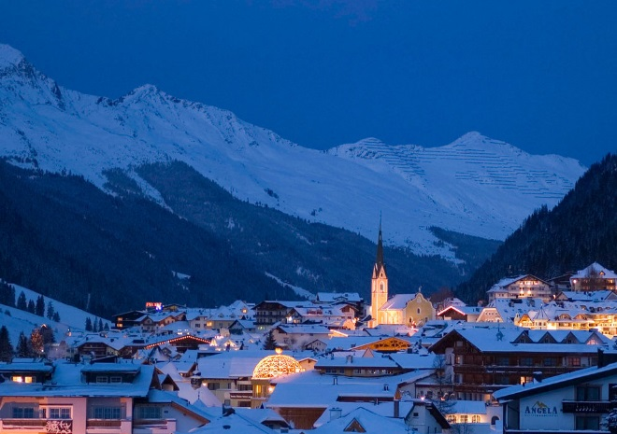

Since the 1960s, the small Tirolian village of Ischgl has been the premier Austrian destination for German visitors, but more recently it has also acquired a strong following others around the world. This has largely come about not just because of the quality of its pistes, but also because of the music.
Ischgl’s famous start and end-of-season Top of the Mountain concerts have attracted an A-list of international stars that have included Elton John, Bob Dylan, Tina Turner, Mariah Carey, the Beach Boys and Kylie Minogue.
As for the slopes, they are extensive, snow-sure, sunny and mostly above the tree line, with some magnificent scenery. The Silvretta Arena ski area extends across the Swiss border to the Engadin resort of Samnaun, and best suits mileage-hungry intermediates who enjoy covering lots of ground each day before returning to the resort for some of the wildest apres ski in the Alps.
Ischgl's village remains traditional Tirolian in style, but with some contemporary touches. There is an airport-style travelator in a tunnel through a giant rock which connects the two ends of Ischgl.
Registration made through the GGRSC web site: www.ggrsc.org
Must be a 2021 GGRSC ski club member.

Contact Ed Kisscorni for details and itinerary
290 Suncrest Court, SW Grandville, MI 49418 616/443-6730
Email: EdKisscorni@Gmail.com

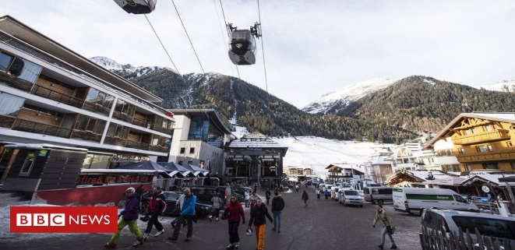
The main ways up to the slopes are via three heavyweight gondolas. One at each end of the resort go to the main mid-mountain hub of Idalp at 7,540 feet, while a third goes to Pardatschgrat at 8,560 feet.
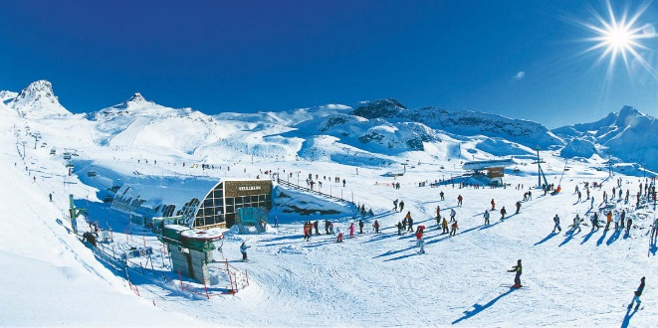
Ischgl's après ski caters largely for those aged 30 to 50 and for those that want that kind of thing there are more clubs in Ischgl than anywhere else in the Alps. For those that don't, there's still an enjoyably buzzing atmosphere that lasts into the evening with the main street always buzzing with activity.
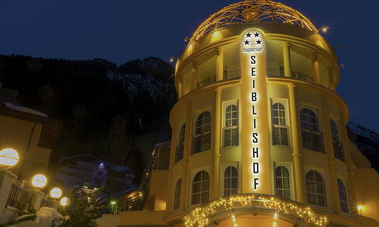
The GGRSC will be staying at the newly renovated Hotel Seiblishof which is located on the edge of the village within a 5 minute walk to the Silvretta gondola and the main village street for entertainment and shopping..

